**What Is Expressions in JAVA**

Expressions are building blocks off all JAVA programs which are made up of [variables](http://abhiandroid.com/java/variables-with-examples), [operator](http://abhiandroid.com/java/operators-in-java)s, and [method](http://abhiandroid.com/java/method) invocations. The expression are created according to the [syntax](http://abhiandroid.com/java/syntax.html) and evaluates to a single value.

double kilometres = (50 * 1.609344);

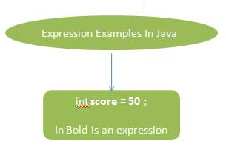

**public** **class** ArithmaticOp {

**public** **static** **void** main(String[] args) {

// **TODO** Auto-generated method stub

**int** x=20;

**if**(x == 20){

System.***out***.println(" This is an Expression" );

}

}

}

Output

This is an Expression